**LAB # 05**

**Spring 2024**

**CSE-204L**

**Operating System Lab**

Submitted by: **NAVEED AHMAD**

Registration No.: **22PWCSE2165**

Class Section: **B**

“On my honor, as student of University of Engineering and Technology, I have neither given nor received unauthorized assistance on this academic work.”

Student Signature: ______________

Submitted to:

**Engr. Abdullah Hamid**

14 April 2024.

Department of Computer Systems Engineering

University of Engineering and Technology, Peshawar

**TASK 01:**

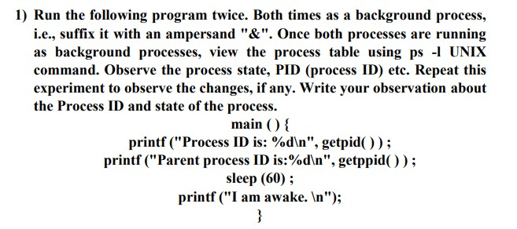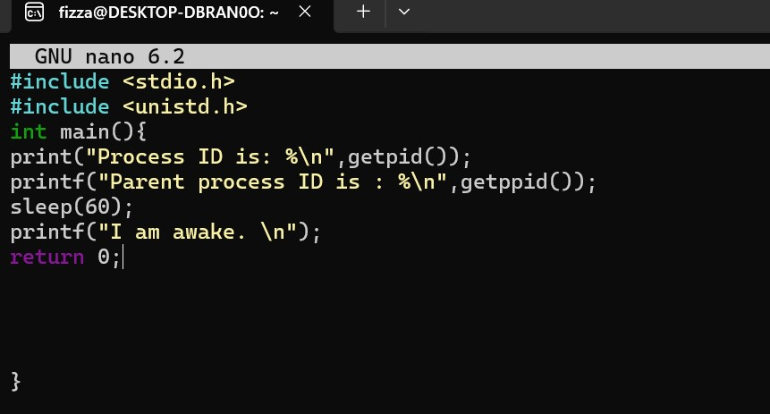

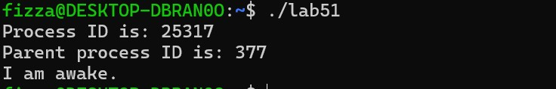

**TASK 02:**

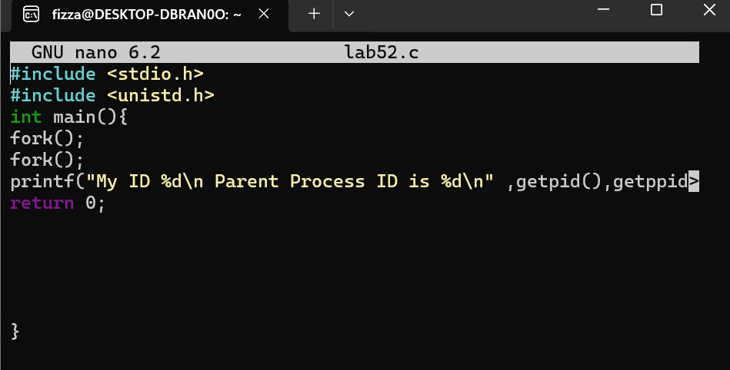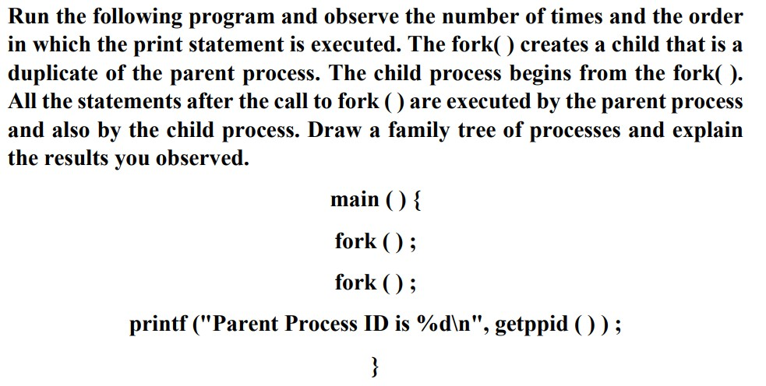

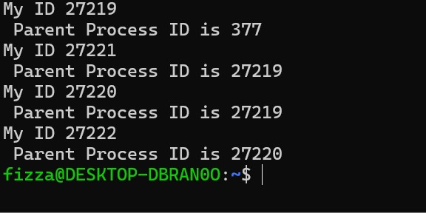

**TASK03:**

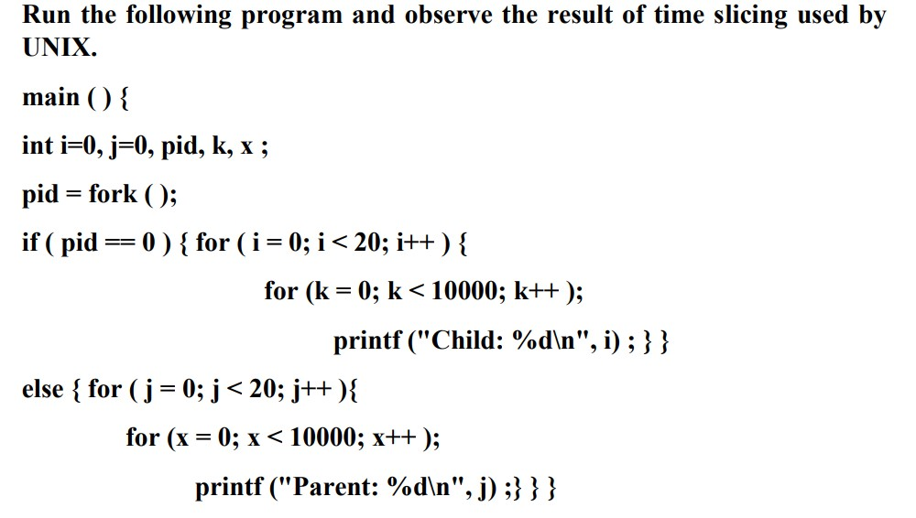

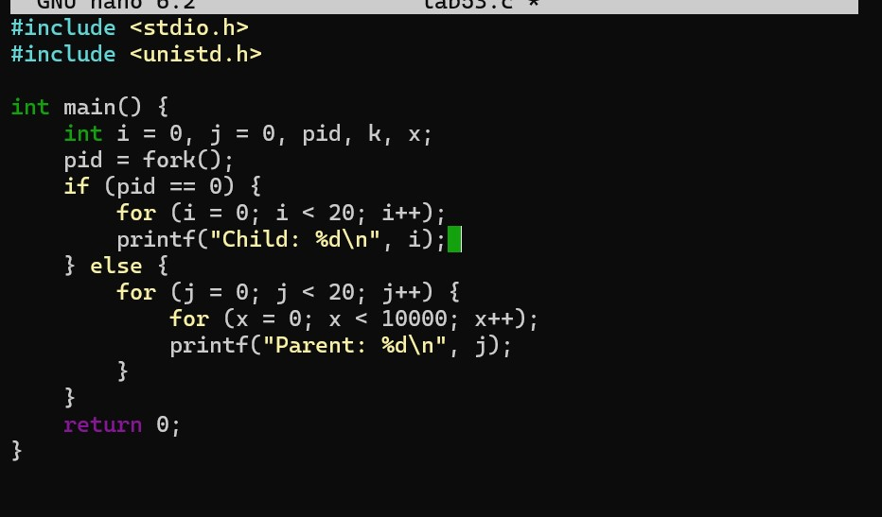

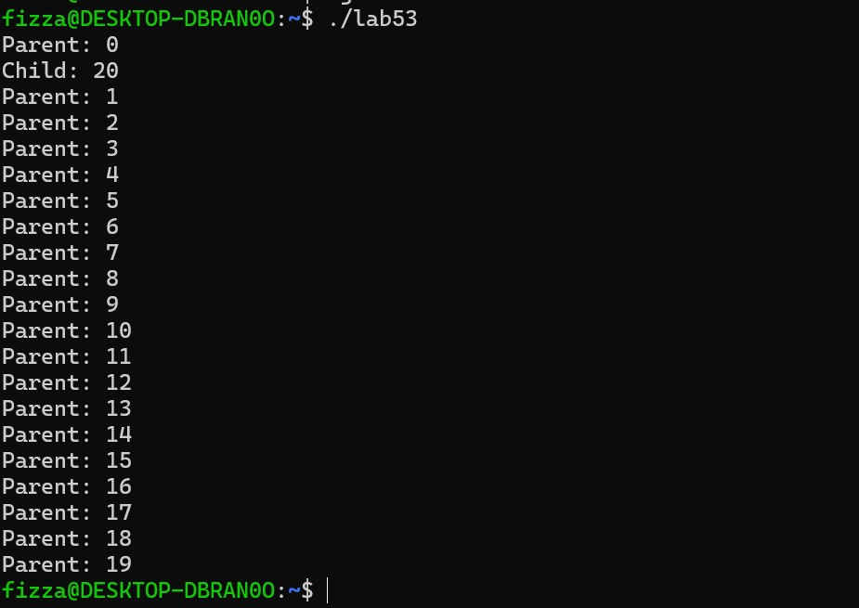

**TASK 04:**

SGXXSYUG

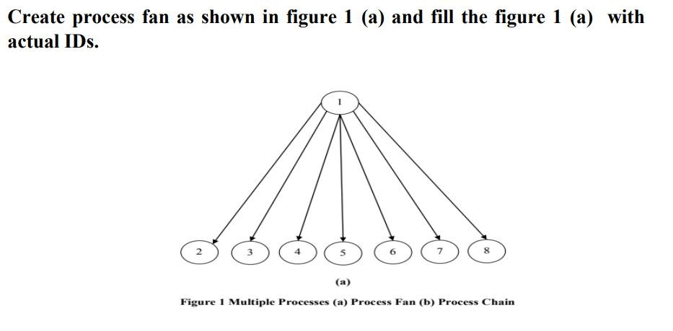

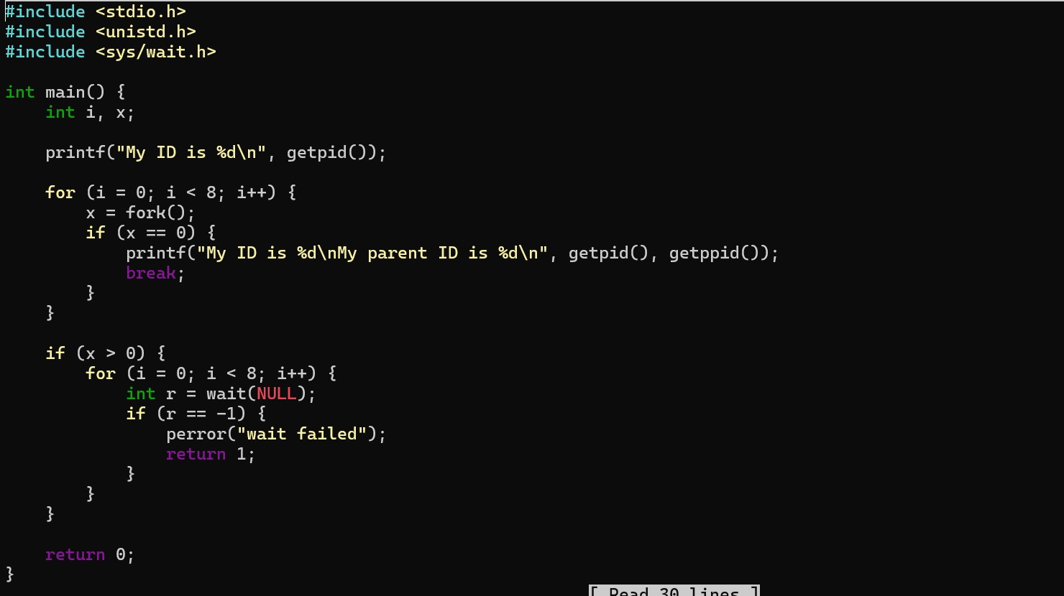

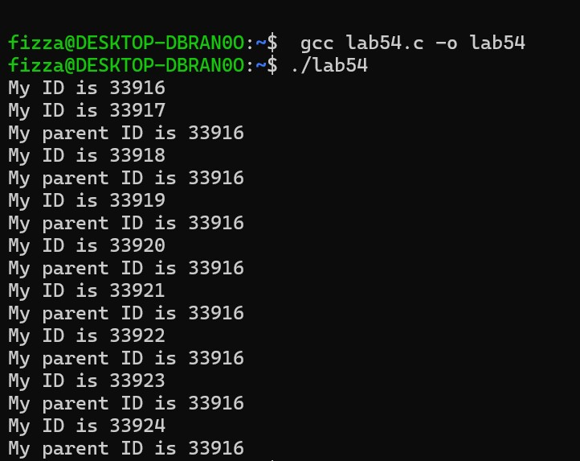

**TASK 05:**

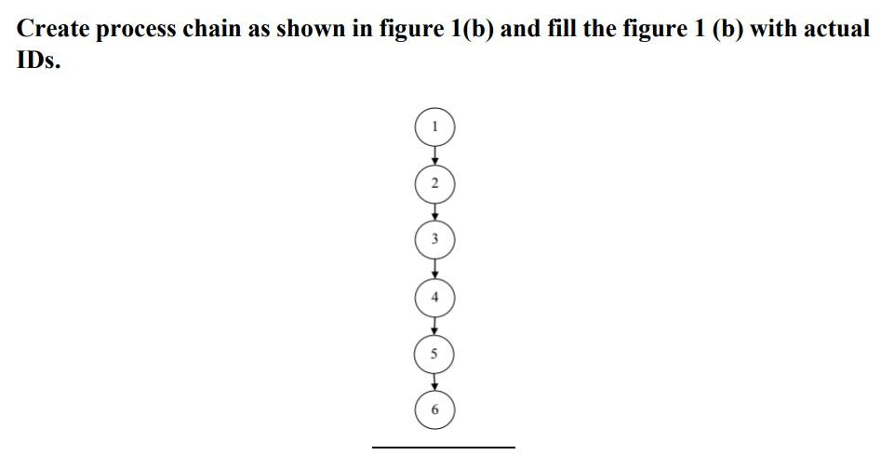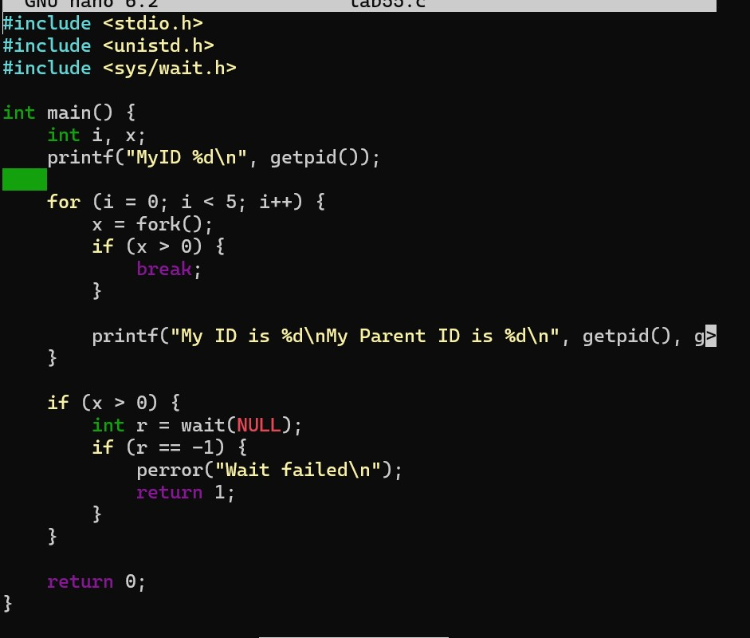

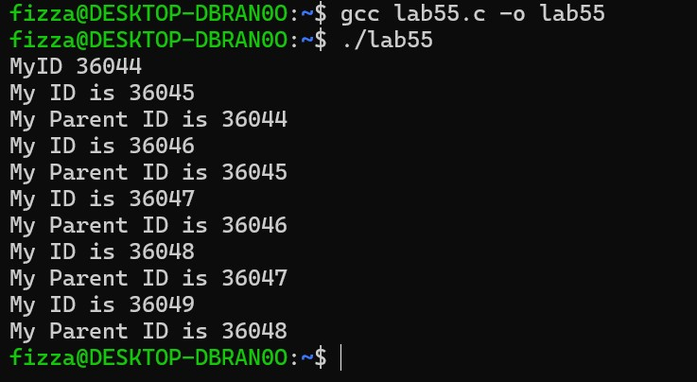

**TASK 06:**

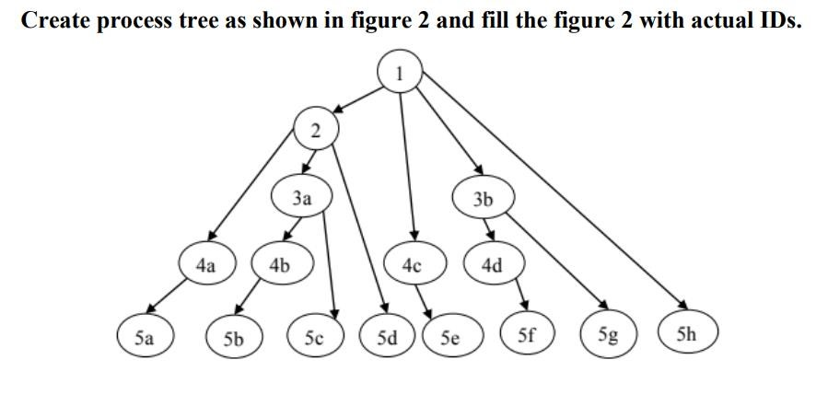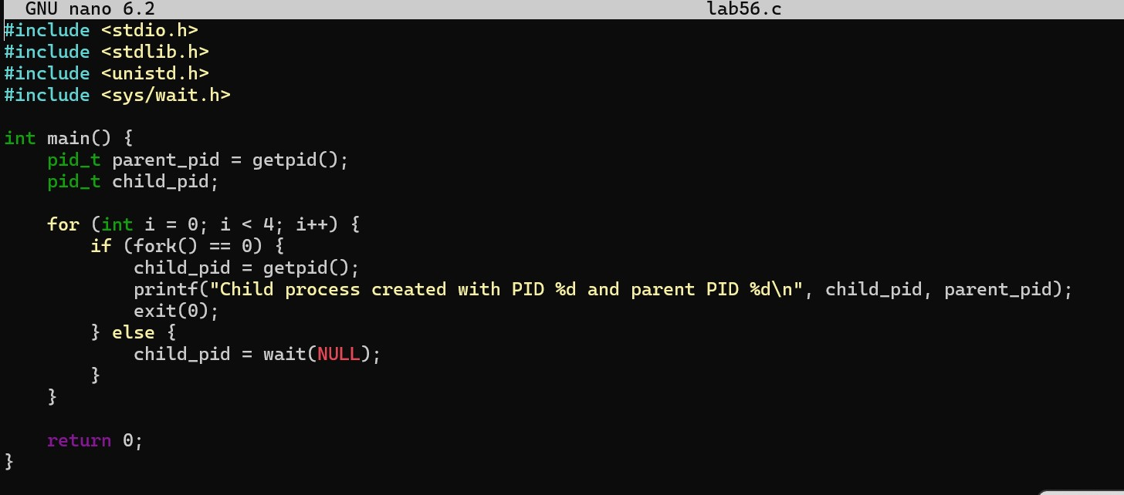

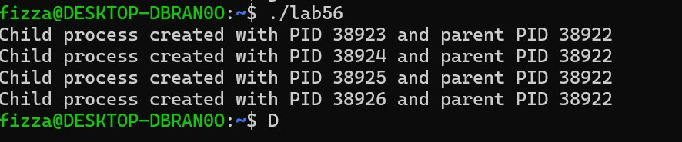

|  |  |  |  |  |
| --- | --- | --- | --- | --- |
| **Marking**  **Criteria** | **Exceeds expectation (2.5)** | **Meets expectation (1.5)** | **Does not meet expectation**  **(0)** | **Score** |
| **1. Correctness** | Program compiles (no errors and no warnings).Program always works correctly and meets the specification(s). Completed between 81-100% of the requirements. | Program compiles (no errors and some warnings). Some details of the program specification are violated, program functions incorrectly for some inputs. Completed between 41- 80% of the requirements. | Program fails to or compile with lots of warnings. Program only functions correctly in very limited cases or not at all. Completed less than 40% of the requirements. |  |
| **2. Delivery** | Delivered on time, and in correct | Not delivered on time, or slightly incorrect format. | Not delivered on time or not in correct format. |  |
| **3. Coding**  **Standards** | Properindentation, whitespace, line length, wrapping, comments and  references. | Missing some of whitespace, line length, wrapping, comments or references. | Poor use of whitespace, line length, wrapping, comments and references. |  |
| **4.Presentation of document** | Includes name, date, anassignment title. Task titles, objectives, output screenshots included and good formatting and excellently organized. | Includes name, date, and assignment title. Task titles, objectives, output screenshots included and good formatting. | No name, date, or assignment title included. No task titles, no objectives, no output screenshots, poor formatting. |  |

**Instructor:** Name: Engr. Abdullah Hamid Signature: ______________________